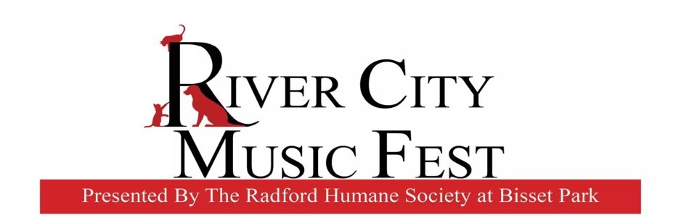

March 9, 2020

Hello Vendors!
We have exciting news regarding this year’s music fest. We are partnering with the City of Radford and The Literacy Volunteers of The New River Valley, to make this year’s event bigger and better than ever. We are also moving our location to the old pool parking area– the location of the Rollin’ on the River Food Truck Rodeo. The area offers more shade and a more intimate setting.
The day’s events include the Tri-Wizard Race and a New River Cleanup, followed by the Humane Society’s Music Fest. The activities will start in the morning and go all day. These events will easily draw over a thousand people into the park. This is a wonderful opportunity for all vendors. We would love to turn this into a true Food Truck Rodeo and Crafter Event. Please help us turn this into an amazing day of family and pet friendly fun - full of good food, amazing crafts, and great music!
Thank you in advance for your support!

Emily Lawrence
Event Coordinator
Radford Humane Society

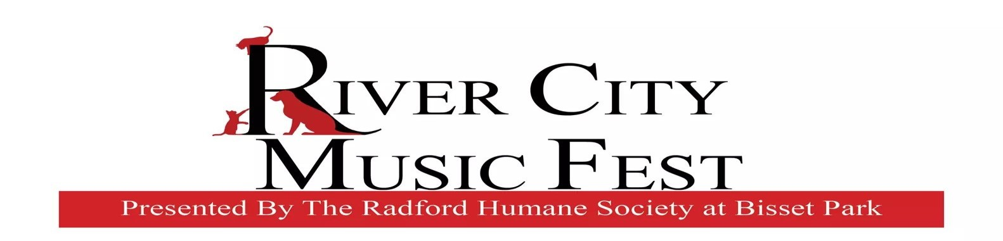

Arts and Crafts Vendor Application Form
Event Information: This is the 9th annual benefit concert for the Radford Humane Society. All proceeds go to support the Radford Humane Society’s Emergency Fund, Spay/Neuter Program, and Building Fund.
Bisset Park is a beautiful setting for a relaxing afternoon of great music and family fun!
Vendor Application Process: Please complete the application and return it to the address listed below. Once the application has been received and approved, you will be contacted.
One Day City Business License Fee: $5.75—This is mandatory, enforced by the city.
Electricity Fee $10: If spaces are available—First come, First serve.

Payment is due at time of application. Applications and payment are
Make checks payable to Radford Humane Society. Please write RHS Concert on the memo line. Please mail applications and checks to:
Radford Humane Society
P.O. Box 581
Radford, VA 24143

**Applications must be received by August 17, 2020**

Arts and Crafts Vendor Application Form
Vendor Booth Fee is $50.00
One Day City Business License Fee is $5.75
Name: __________________________________________________________

Address: ________________________________________________________

Phone: _______________________ Home ________________________Cell

Email: __________________________________________________________

Name of Business: _________________________________________________

Type of Art/Craft/Product: __________________________________________

Electricity– Yes _____ No______

Total Paid (include $5.75 City Business License Fee) : $ ___________________ Signature:______________________________ Date:_____________________

**Applications must be received by August 17, 2020**

Arts and Crafts Vendor Application Form

Vendor Booth Fee is $50.00
One Day City Business License Fee is $5.75

Policies and Procedures:

- Space assignments will be made by the RHS Concert Committee.
- All vendors should be set up by 11am and expect to stay until 6pm.
- The Radford Humane Society and the City of Radford cannot assume liability for loss, damage or injury.
- The Radford Humane Society reserves the right to reject applications, in which case, payment will be refunded.
- No refunds will be given after August 17, 2020.
- The completed and signed application shall constitute the agreement to comply with all listed conditions.
- Electricity is on a First Come/First Serve basis.

**Applications must be received by August 17, 2020**

