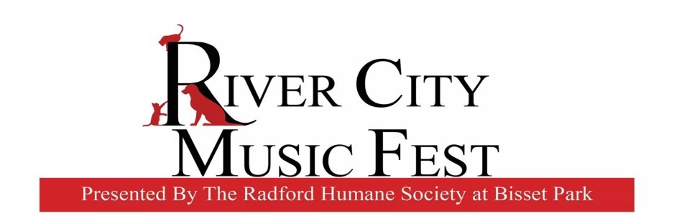

March 9, 2020

Hello Vendors!
We have exciting news regarding this year’s music fest. We are partnering with the City of Radford and The Literacy Volunteers of The New River Valley, to make this year’s event bigger and better than ever. We are also moving our location to the old pool parking area– the location of the Rollin’ on the River Food Truck Rodeo. The area offers more shade and a more intimate setting.
The day’s events include the Tri-Wizard Race and a New River Cleanup, followed by the Humane Society’s Music Fest. The activities will start in the morning and go all day. These events will easily draw over a thousand people into the park. This is a wonderful opportunity for all vendors. We would love to turn this into a true Food Truck Rodeo and Crafter Event. Please help us turn this into an amazing day of family and pet friendly fun - full of good food, amazing crafts, and great music!
Thank you in advance for your support!

Emily Lawrence
Event Coordinator
Radford Humane Society

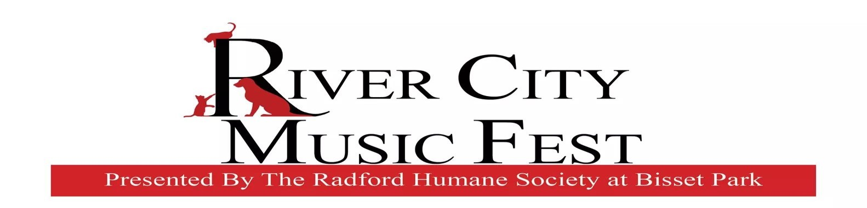

Food Vendor Application Form
Event Information: This is the 9th annual benefit concert for the Radford Humane Society. All proceeds go to support the Radford Humane Society’s Emergency Fund, Spay/Neuter Program, and Building Fund.
Bisset Park is a beautiful setting for a relaxing afternoon of great music and family fun!
Vendor Application Process: Please complete the application and return it to the address listed below. Once the application has been received and approved, you will be contacted.

Payment is due at time of application. Applications and payment are due by August 7, 2020.
Make checks payable to Radford Humane Society. Please write RHS Concert on the memo line. Please mail applications and checks to:
Radford Humane Society
P.O. Box 581
Radford, VA 24143

**Applications must be received by August 7, 2020**

Food Vendor Application Form
Policies and Procedures:
- Each space rents for $75 per space. There is also a $5.75 One Day Business License, required by the city of Radford, if you do not have a city business license. Meals Tax will be required. Attached is a copy of the Meals Tax Registration Form and Computation Sheet. This will need to be filed with the Commissioner of Revenue, 616 Second Street, Radford, VA 24141. Meals Tax MUST be paid in order to participate in any City Events. Assignments will be made by the RHS Concert Committee.
- All vendors should be set up by 11am and expect to stay until 6pm.
- The Radford Humane Society and City of Radford cannot assume liability for loss, damage or injury.
- The Radford Humane Society reserves the right to reject applications, in which case, payment will be refunded.
- No refunds will be given after August 7,2020.
- The completed and signed application shall constitute the agreement to comply with all listed conditions.
- Food vendors must comply with Virginia Health Department regulations:
1 - complete and attach the “Temporary Event Application” form.
2– If you have a mobile unit or annual permit, please attach a copy.
  - – If you don’t have a current permit, submit a check for $40 made payable to Radford City Health Department with your application.
  - Attach a copy of your ServeSafe Certificate.
Return all information by August 7, 2020 to Radford Humane Society.
- Electrical service will be available on a first come first serve basis. There is an $10 fee in addition to the Food Vendor Fee. Please be sure to request electricity on your application. If not requested and paid for, you will absolutely NOT be provided with electrical service. Extension cords will not be provided. Vendors must bring their own extension cords.

Food Vendor Application Form
Name: ___________________________________________________________
Address: _________________________________________________________
Phone: ________________Home __________________Cell
Email: ___________________________________________________________
Name of Business:_________________________________________________ Social media pages or links: _________________________________________ Type of Food:_____________________________________________________
Truck____________ Trailer_____________ Booth_____________
Electricity—$10 additional fee (must provide own extension cord): ___Yes___No
***Virginia Department of Health “Temporary Event Form” and ServeSafe Certificate must accompany this application. Also send a copy of mobile unit/ annual permit or $40 check to Radford City Health Department.**
Food vendor space @ $75 each $_________
Radford City One Day Business License $ 5.75 $_________
Health Dept. application, ServeSafe Certificate, copy of permit or $40 fee ___
Electricity hook up needed @ $10 $_________
Total $_________
Signature: ______________________________ Date: _____________________
Mail completed application to: Radford Humane Society
P.O. Box 581 Radford, VA 24143

Arts and Crafts Vendor Application Form
Event Information: This is the 9th annual benefit concert for the Radford Humane Society. All proceeds go to support the Radford Humane Society’s Emergency Fund, Spay/Neuter Program, and Building Fund.
Bisset Park is a beautiful setting for a relaxing afternoon of great music and family fun!
Vendor Application Process: Please complete the application and return it to the address listed below. Once the application has been received and approved, you will be contacted.
One Day City Business License Fee: $5.75—This is mandatory, enforced by the city.
Electricity Fee $10: If spaces are available—First come, First serve.

Payment is due at time of application. Applications and payment are
Make checks payable to Radford Humane Society. Please write RHS Concert on the memo line. Please mail applications and checks to:
Radford Humane Society
P.O. Box 581
Radford, VA 24143

**Applications must be received by August 17, 2020**

Arts and Crafts Vendor Application Form
Vendor Booth Fee is $50.00
One Day City Business License Fee is $5.75
Name: __________________________________________________________

Address: ________________________________________________________

Phone: _______________________ Home ________________________Cell

Email: __________________________________________________________

Name of Business: _________________________________________________

Type of Art/Craft/Product: __________________________________________

Electricity– Yes _____ No______

Total Paid (include $5.75 City Business License Fee) : $ ___________________ Signature:______________________________ Date:_____________________

**Applications must be received by August 17, 2020**

Arts and Crafts Vendor Application Form

Vendor Booth Fee is $50.00
One Day City Business License Fee is $5.75

Policies and Procedures:

- Space assignments will be made by the RHS Concert Committee.
- All vendors should be set up by 11am and expect to stay until 6pm.
- The Radford Humane Society and the City of Radford cannot assume liability for loss, damage or injury.
- The Radford Humane Society reserves the right to reject applications, in which case, payment will be refunded.
- No refunds will be given after August 17, 2020.
- The completed and signed application shall constitute the agreement to comply with all listed conditions.
- Electricity is on a First Come/First Serve basis.

**Applications must be received by August 17, 2020**

